**Seminar**

**Gas Sensor Principles and Development of Laboratory Testing Systems**

**Presenter: Dr. Mehdi Ranjbar**

**Department of Physics, Isfahan University of Technology**

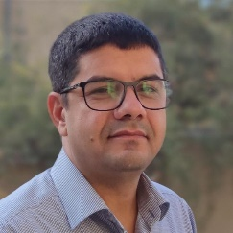

**Date: Tuesday (1404/3/6) 12.00 AM ; Place: Seminar Hall, Department of Chemistry**

Gas sensors play a vital role in diverse fields including environmental monitoring, industrial safety, healthcare diagnostics, and smart agriculture. This presentation will review the applications, technologies, and chemical and physical foundations of gas sensing, emphasizing how gas molecules interact with sensing materials at the surface through adsorption, redox reactions, and catalytic processes. The impact of functionalization, hybrid materials, and nanostructures on sensitivity and selectivity will be discussed. We will also highlight the physical parameters affecting sensor behavior, such as temperature, surface states, and electron transfer processes, and how these factors can be optimized in real-world applications. The second part will be devoted to the instrumentation required in a research laboratory—including controlled test chambers, gas flow systems using mass flow controllers, and temperature/humidity regulation—along with data acquisition tools for real-time monitoring. Furthermore, we will introduce a cost-effective gas sensing system developed specifically for research environments through knowledge-based activities. The system is designed to provide flexible control, reliable data collection, and compatibility with a wide range of sensor types - making it a valuable platform for experimental studies and prototype development in this field.

